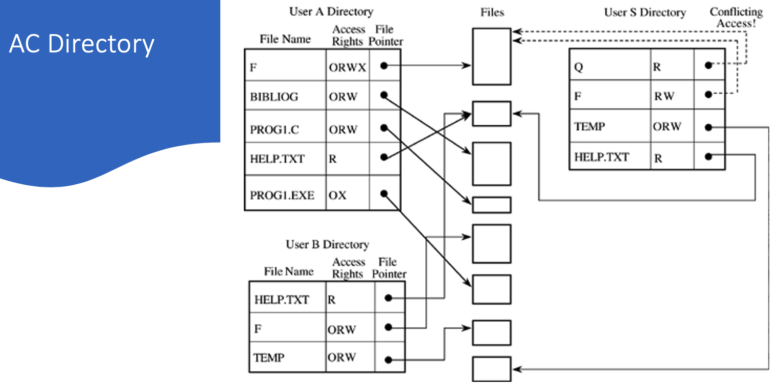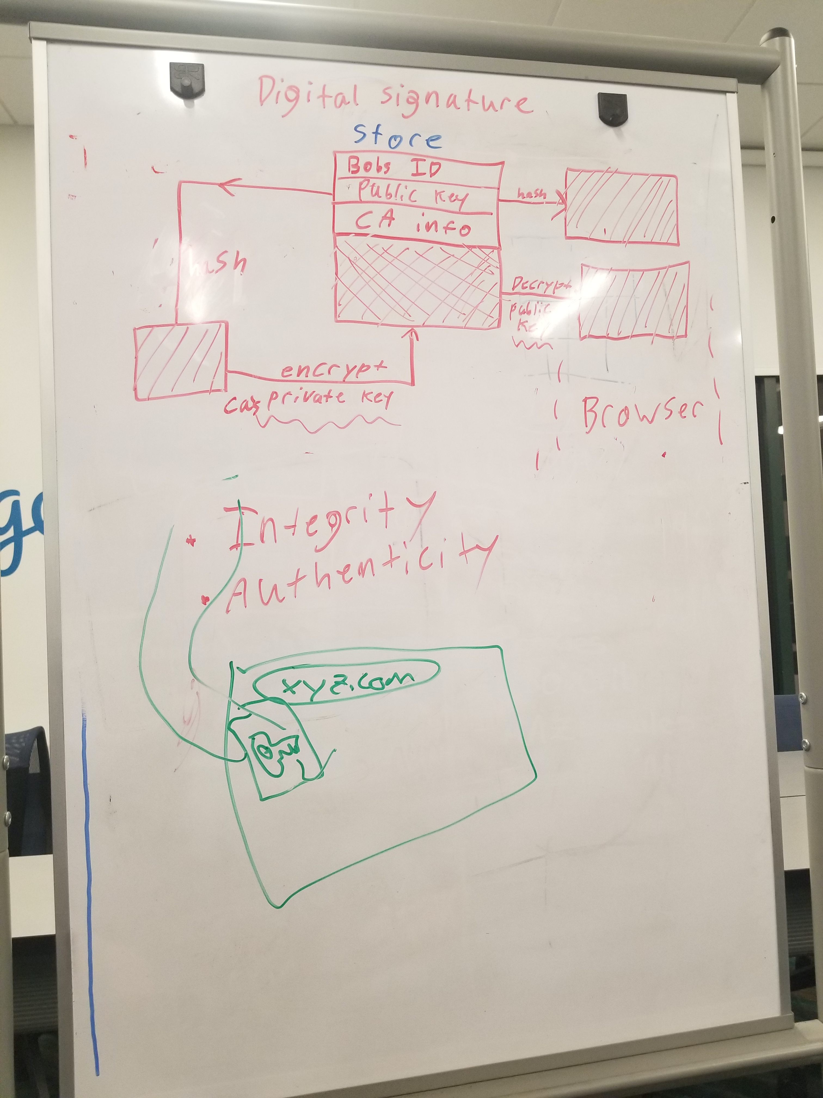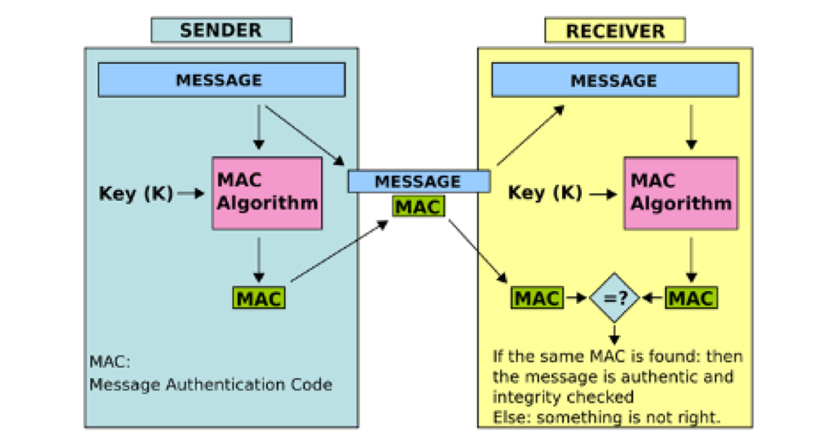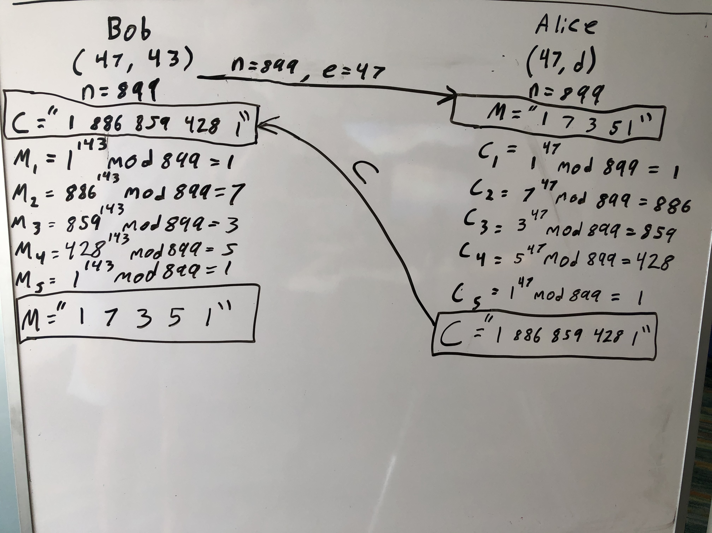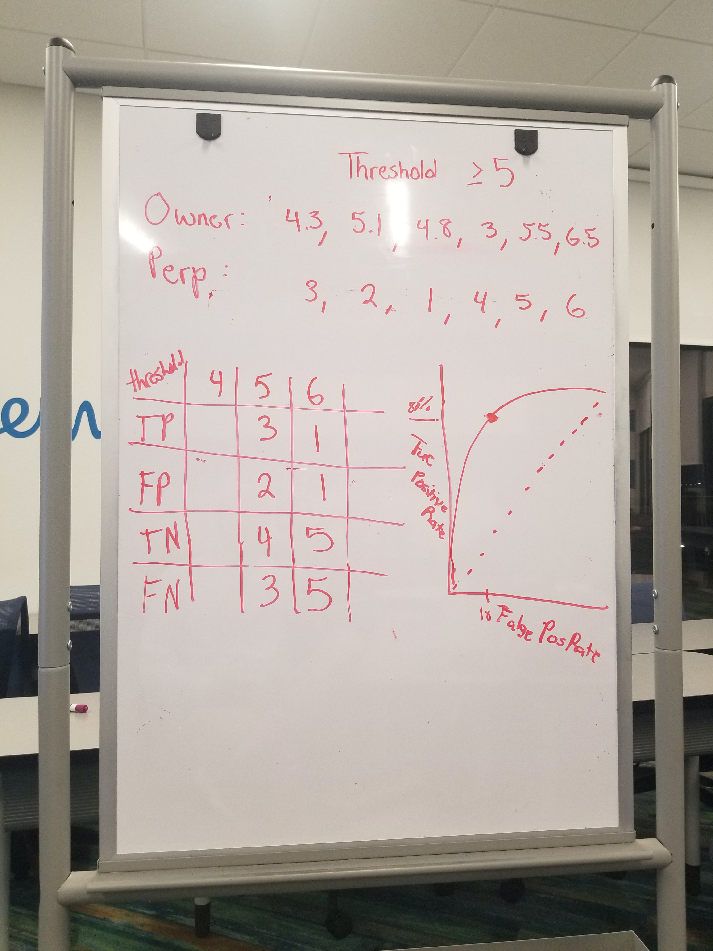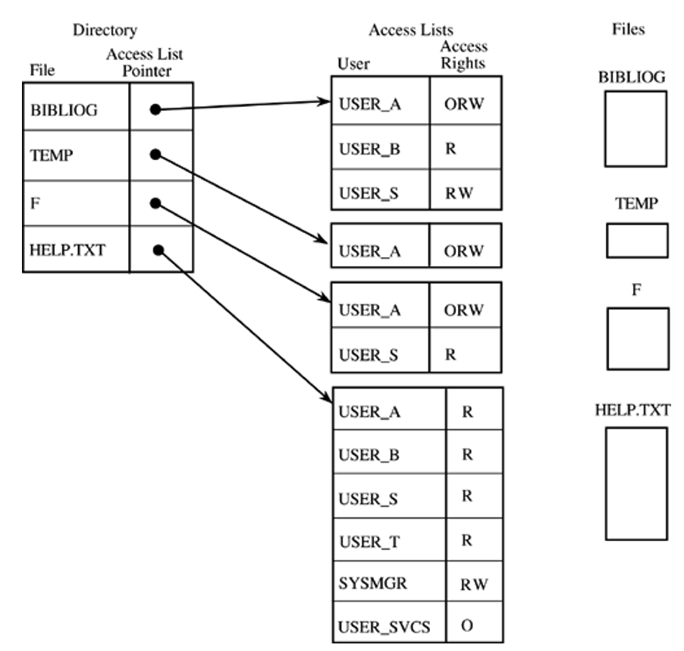

**Threat Modeling**

•Assets: What are we trying to protect? How valuable are those assets?

•Adversaries: Who might try to attack, and why?

•Vulnerabilities: How might the system be weak?

•Threats: What actions might an adversary take to exploit vulnerabilities?

•Risk: How important are assets? How likely is exploit?

•Possible Defenses

**Security Mindset**

CIANA

Confidentiality

Integrity

Availability

Non-repudiation

Authentication

* What you are, know, have

**Asymmetric Advantage**

The attacker only needs to exploit one weakness

**Security in Depth**

Layers, two factor authentication is SiD if on two different devices. Ex: Biometrics, email verification, encrypt then Mac.

**Kerckhov’s Principle**

* The secrecy of the private key is all that matters. Contrary to the security by obscurity principal.

size(message space) == size(key space) == size(cipher space) 🡺 PERFECT SECRECY

**Authentication Mechanisms**

Types of Password Attacks

* Brute Force
* Dictionary
* Phishing
* Rainbow Table
* Credential Stuffing
* Password Spraying

**Entropy Formula**

Summation of log(base2)(1/p)

ROC ->>>

Sensitivity: TP/# of positives

Specificity: TN/# of negatives

Accuracy: TP + TN / P + N

**Access Controls**

Reference Model - 1.) Tamperproof, always correct, verifies every access attempt

AC Directory -

AC Matrix

AC List

**Cryptography**

**MAC (Message Authentication Code)**

**HMAC (Hash Message Authentication)**